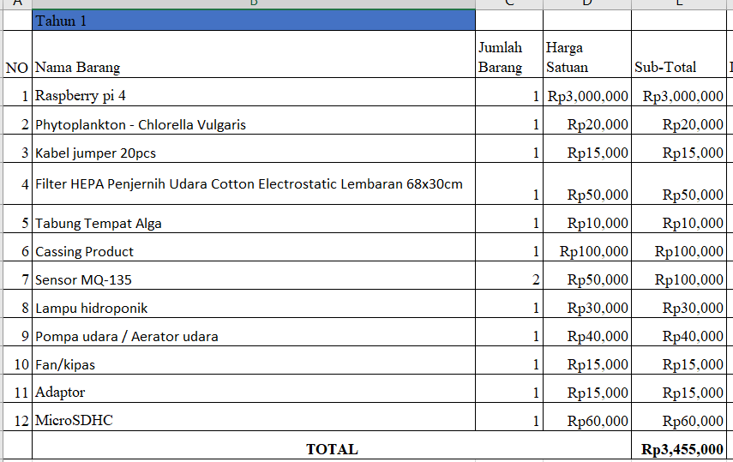**BILL OF MATERIAL (BOM)**